58th INTERNATIONAL TELEVISION FESTIVAL
GOLDEN PRAGUE
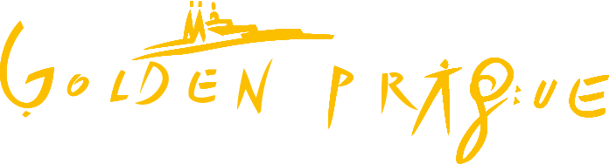

SECURITY MEASURES FOR THE 2021 GOLDEN PRAGUE INTERNATIONAL TELEVISION FESTIVAL
The 58th season of the Golden Prague International Film Festival will be held during 21-25 September 2021. All public health measures in effect at the time of the festival must be strictly observed.
- All guests and visitors must wear a protective covering of the respiratory tract in indoor areas, either a nanofiber facemask or a FFP2/KN95/N95 respirator as a minimum.
- Throughout the venue, signs will be posted to inform visitors of the requirement to wear a respirator, to maintain social distancing of no less than 1.5 meters, and to use designated disinfectant, preferably disinfectant available from touch-free dispensing units.
- Clearly marked waste bins will be placed on the premises for the disposal of respirators.
- A protective plastic glass will be installed in the accreditation kiosk.
- "Infection-free status" will have to be demonstrated during accreditation in an area designated for this purpose – COVID CONTROL POINT. Visitors who pass the check will receive a wrist band. The wrist band will be required for entering all of the areas where the festival will be taking place, including the program of extras.
A wrist band will be issued to visitors who present:
– a QR code on an EU COVID-19 Certificate, either printed out or displayed in the Tečka application),
– a certificate of having recovered from the COVID-19 disease less than 180 days prior to the visit issued by a certified facility,
– a certificate of a valid PCR or antigen test performed by a certified facility. A PCR test is valid for seven days, and an antigen test is valid for three days.
Two kinds of wrist bands will be issued:
– black wrist band with white letters, which will be valid for the entire duration of the festival,
– white wrist band with black letters, which will have limited validity.
The wrist band cannot be obtained at the entrance to the venue!
- Visitors can administer a self-test on the premises using their own self-test kit. The test must be carried out at the COVID CONTROL POINT in front of a staff member to whom a negative test result must be handed over. This self-test is valid for 1 day. If required, the jurors and EBU and IMZ members will receive a COVID-19 self-test kit from the organizer.
Closest COVID-19 testing facilities (advance registration is required): Městská poliklinika Praha Spálená (Mon-Fri, PCR 8-14, Antg 14-16), GenDetective s.r.o. Karlovy lázně (Mon-Sun, PCR 8-18), GHC Genetics Václavské náměstí (Mon-Sun, PCR 8-18, Antg 8-12), GHC Genetics Mariánské náměstí (Mon-Sun, PCR + Antg 8-19/18).
- During accreditation, all foreign visitors will receive general information on what to do in case they experience health problems or come into contact with a positively tested person.
- The venue of the festival will be regularly disinfected by cleaning staff. The ballet room will be disinfected between conferences. The jury room will be disinfected between meetings. Kiosks where public screenings are held will be disinfected after the departure of visitors. Other areas will be disinfected in an ongoing manner.
- Meeting rooms will be disinfected overnight using ozone.
- During conferences, a maximum possible social distancing will be maintained between visitors.
- Washrooms will be frequently cleaned. There will be a washroom cleaning checklist on the inside of the washroom door.
- The measures might be modified in response to the current requirements imposed by government authorities.
Festivals · Covid Portal (gov.cz)
Ministry of Health of the Czech Republic – Requirements and recommendations for theater, film, and music festivals.

Requirement to wear protective covering of the respiratory tract in outdoor areas · Covid Portal (gov.cz)
Ministry of Health of the Czech Republic – Requirement to wear a respirator outdoors

The Protective Measure regarding the conditions of entry into the Czech Republic - The Ministry of Health
https://www.mvcr.cz/mvcren/article/coronavirus-information-of-moi.aspx

